here I used mailgun to send text it can also used for sending images from raspberry pi to mail

step 1 install libraray

sudo su

pip install requests

sudo apt-get update

sudo apt-get upgrade(it might take some time)

step 2 setup mailgun

code reference for python from mailgun documentation

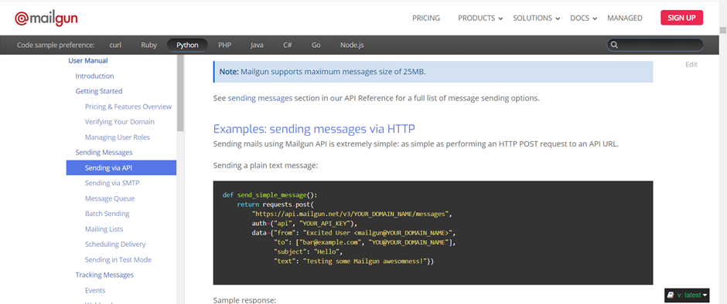

<https://documentation.mailgun.com/en/latest/user_manual.html#sending-via-api>

sign up to mailgun

grab your api key from dashboard of mailgun

copy to code

and change code according to your mailgun domain

save code

step3 run program

python mail.py